SAFETY ALERT

To : All Scaffold Operatives and Staff

c.c. : Des Moore

From : Safety Department

Date : 06-Jun-12

Subject : Danger of Joint Pins Falling out of Apollo Beams

There was a recent incident where scaffolders were chaining Apollo beams down the outside of a scaffold when an internal joint pin slid down inside the beam and shot out of the end. There was a large double boarded gantry in place, but unfortunately the joint pin missed the gantry and landed on a pavement 20m below and which could have had very severe consequences.

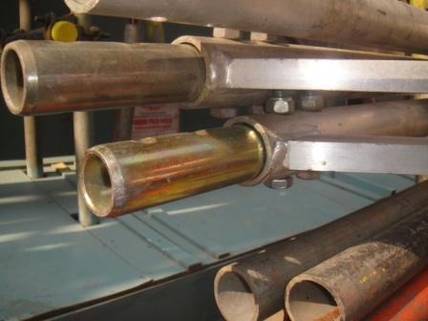

TRAD intend to spot weld the bolts holding the joint pins in position, but until all beams are returned to the yard, you must do the following to prevent a similar incident:

- The Lead Scaffolder to ensure that there is full protection in place for the public;
- Only after he has carried out his inspection can work begin clearing Apollo beams;
- Scaffolders will carry out a full inspection of the beams prior to handling;
- They will check that the end of the beams are secured with bolts (so nothing can exit the end of the beams);
- They will pass beams down with the bolted pins facing downwards (so there is no risk of material sliding down inside the tube);
- Where there are no joint pins, scaffolders will look down the full length of the tubes to check that there are no hidden joint pins or similar objects;
- Where scaffolders cannot clearly see through the lines of beams – to check for hidden joint pins – then scaffolders will fix joint pins on the ends to ensure that nothing can escape the beams.

Thanks and please Play it Safe,
Steve Kearney, H&S Manager

