SAFETY ALERT

To : All Scaffold Operatives and Staff

c.c. : Des Moore

From : Safety Department

Date : 06-Jun-12

Subject : Danger of Unsafe Layher Toeboard Fixing

There was a recent accident where a Layher stoppend toeboard fell off the end of a scaffold and struck another contractor working below, breaking a bone in his hand.

Please see a photo of the toeboard, which appears to have been erected incorrectly (the short toeboard the site manager is holding can twist out and fall).

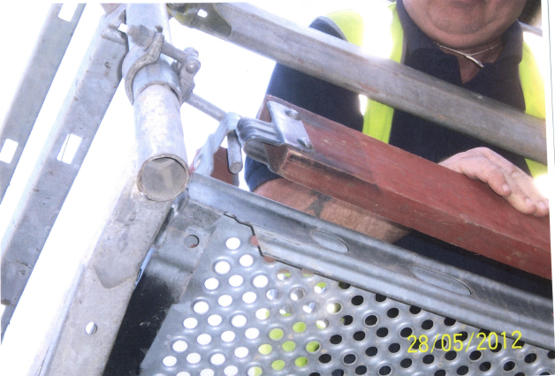

- When fixing these toeboards, ensure the long 2.4m toeboard is fixed the other way around.

- Then fix the smaller toeboard the other way around on top with the pin of the toeboard fitting securing both in position.

Thanks and please Play it Safe,
Steve Kearney, H&S Manager

