SAFETY ALERT

To : All Scaffold Operatives and Staff

c.c. : Des Moore

From : Safety Department

Date : 06-Jun-12

Subject : Fragile Roofs

There was a recent accident where a scaffolder failed to work to the RAMS, which details the Safe System of Work, and used scaffold boards instead of crawling boards (youngmans) to work on the fragile roof.

The scaffolder slipped on the scaffold boards – which wouldn’t have happened if he’d been working on the youngmans – and stepped on to the fragile roof, which gave way and he fell 1.0m into the safety net, sustaining bruising and cuts.

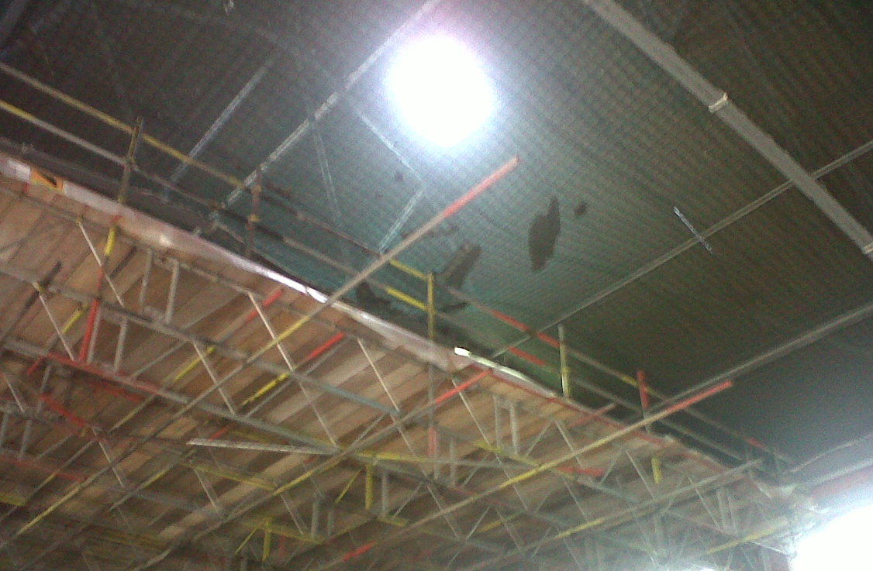

- Your Contracts Manager will have carried out a survey and put control measures in place to protect you (such as birdcages and/or safety nets);
- Always work to the Safe System of Work, detailed in the RAMS;
- Always use crawling boards (youngmans) and never use scaffold boards;
- Never stand on the bolts of the fragile roof – often as in this photo there is no support;
- Work safely at all times and stop work and speak to your supervisor if you cannot do the work as detailed in the RAMS.

Thanks and please Play it Safe,
Steve Kearney, H&S Manager

