Internal MEMORANDUM

To : All TRAD Employees and Workers

c.c. : Des Moore

From : H&S Department

Date : 24-Sep-12

Subject : Random D&A Testing of TRAD Employees and CIS Workers

In June this year TRAD reviewed and revised the H&S Policy to include increased checks on its employees and CIS workers regarding D&A testing.

From October this year, TRAD will begin random D&A Testing of its employees and CIS workers.

You may be contacted by your Contracts Supervisor or Manager and asked to attend the testing centre, London Clinic, near Canada Water, to take a Random D&A Test (and full details of the address will be given to you at the time).

For your own information:
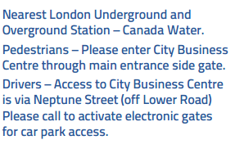

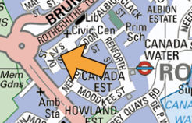

London Clinic
8, City Business Centre, Lower Road, London, SE16 2XB / Tel: 020 7500 6900

Failure to attend the centre and give a sample will be treated as Gross Misconduct and a disciplinary process will be put into place (the outcome of which is likely to be dismissal).

Thanks and please Play it Safe,
Steve Kearney, H&S Manager

