SAFETY ALERT

To : All Scaffold Operatives and Drivers

c.c. : Des Moore

From : Safety Department

Date : 19-Apr-12

Subject : Danger of Lorry Trailers Tipping

There was a recent incident where an experienced advanced scaffolder unloaded the back of the trailer, and the weight of the bins of fittings caused the trailer to tip dangerously forward.

Luckily no one was hurt when the front of the trailer struck the ground – we may not be so lucky next time if we were to allow a next time!

Please ensure that:
- When a trailer is dropped on site, you unload (or load) the trailer safely;
- Access the trailer by secured ladder and work behind double handrails;
- Unload the front of the trailer – such as bins of fittings –first.

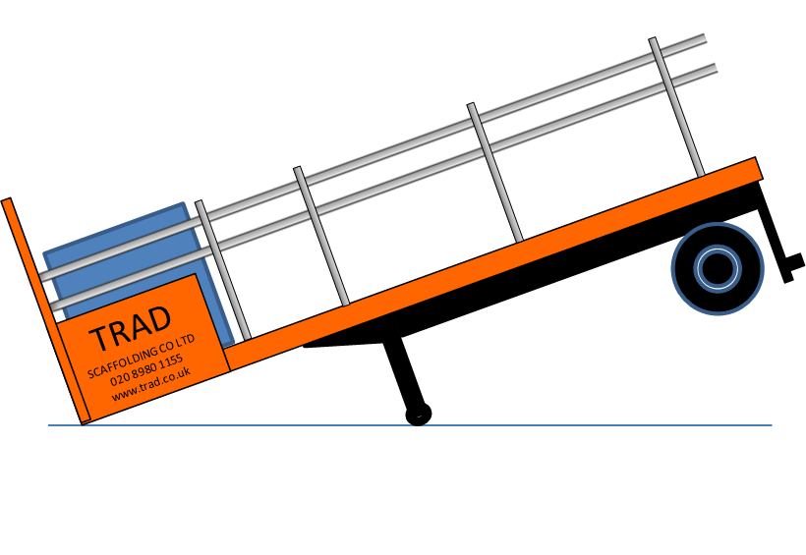
Note: Failure to unload the front first (see below) can result in the trailer tipping:


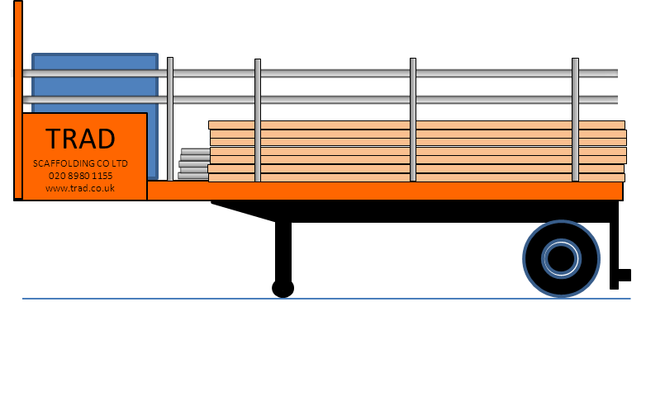

- Always maintain segregation with barriers and signs and stop work if there is a problem;
- Do the same when you’re loading – do not load the front of the trailer first;
- Once the lorry is unloaded, climb down the ladder, remove all barriers and signs.

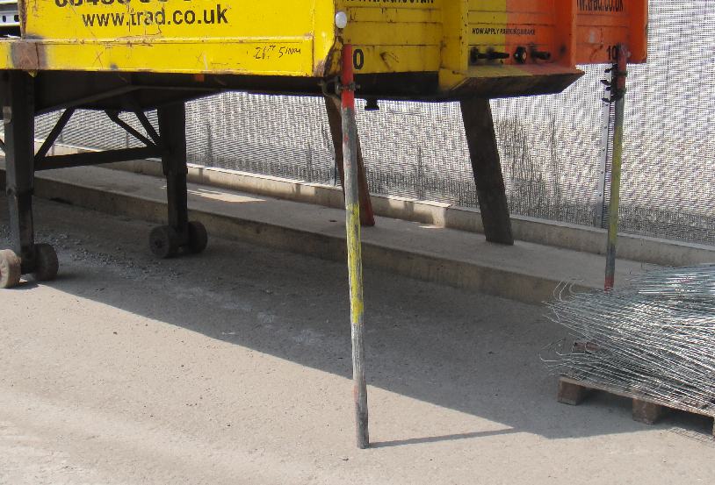
Note: never prop the trailer up with bits of scaffold tube – it is not safe and risks a dangerous collapse.

Be Safe,
Steve Kearney, H&S Manager

